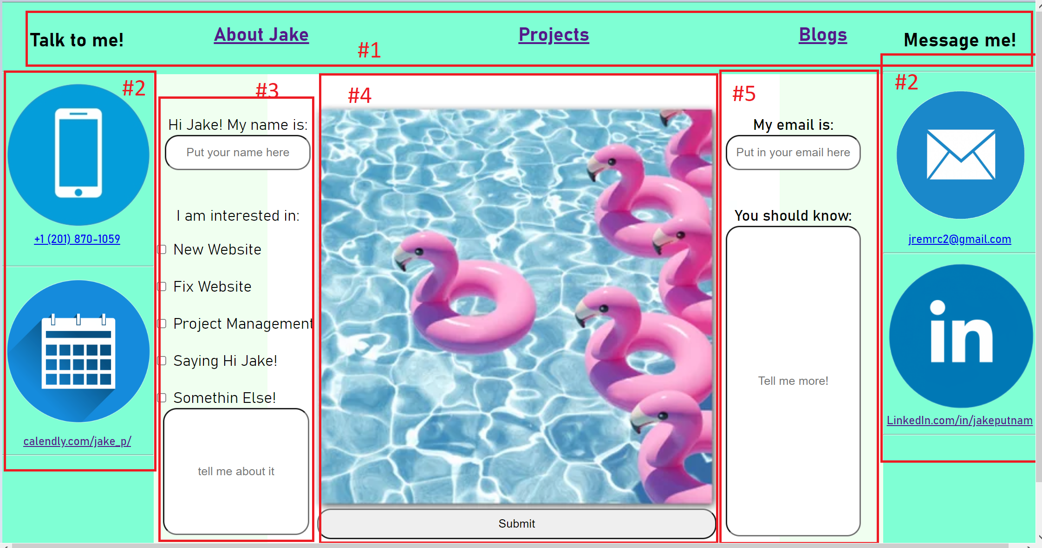

#1

|  |  |  |  |
| --- | --- | --- | --- |
| Make all 1 Nav Section | Position=Fixed | Change Font | Links stay same & change active color |

#2

|  |  |  |  |  |
| --- | --- | --- | --- | --- |
| All Logos same size | All logos aligned | Position = fixed | Same width | Center header text |

#3&5

|  |  |  |  |  |
| --- | --- | --- | --- | --- |
| Same Width | Aligned Vertical Text | Same fonts & Size & color | Same Margins | Center header text |

#4 Make them both the same section, same width